WHAT IS INSIDE A NUMBER?

This is a beautiful, rich open-ended question. So, before exploring, ask this question and then keep asking it. We tend to think of numbers as inert, as being only what we see at first glance, but what if we imagine that numbers have hidden bones? And if we crack numbers we’ll see that something marvelous lies hidden inside. And even more we’ll unlock some of the deepest truths about numbers and get a great addition, multiplication, and fraction workout along the way. Here are three ideas or possible answers to this question.

1. What is inside a number?
an infinite series approach
$$\frac{1}{2}+\frac{1}{4}+\frac{1}{8}+\frac{1}{16}+…=1$$ | 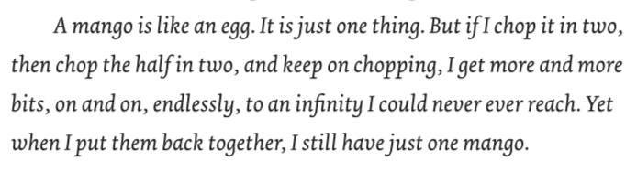

The box is just one thing.  Chop it in half (yellow).  Chop one of those halves in half  (pale pink).  Chop one of those halves in half  (baby blue).  And on and on.  Could you keep going forever?  And if you put all the pieces back together, you still get just one box. | Take a single piece of string.  Cut the string in half.  Cut one of those halves in half.  Keep going.  Theoretically you could keep going forever, but something stops you in practice. Discuss!  And just like the box and the mango when you put it all back together, you get a single piece of string.
Notice, you can do all this thinking without talking about fractions. But what you are really thinking through is the infinite sum of fractions above. Just think, we’ve cracked 1 open and found infinity! Now consider watching this wonderful video by Vi Hart about packing an infinite number of things – elephants, circles, camels, triangles – into a finite space.

2. What is inside a number?
a partitions approach, an additive approach

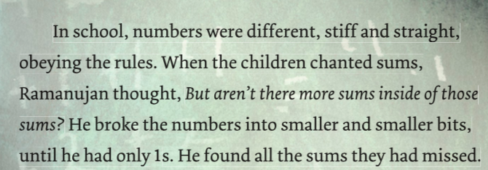 | Partitions are a way of breaking numbers down by addition. I love thinking of these as the additive bones of numbers.

Just have everyone try it. Start small, like with 3 and then 4. Then try 5, 6, and 7. How do you know you have all the possibilities? Here are some so you get the idea:

3 = 3  = 2 + 1  = 1 + 1 + 1 | 4 = 4  = 3 + 1  = 2 + 2  = 2 + 1 + 1  = 1 + 1 + 1 + 1 + 1 | 5 = 5  = 4 + 1  = 3 + 2  = 3 + 1 + 1  = 2 + 2 + 1  = 2 + 1 + 1 + 1  = 1 + 1 + 1 + 1 + 1 | 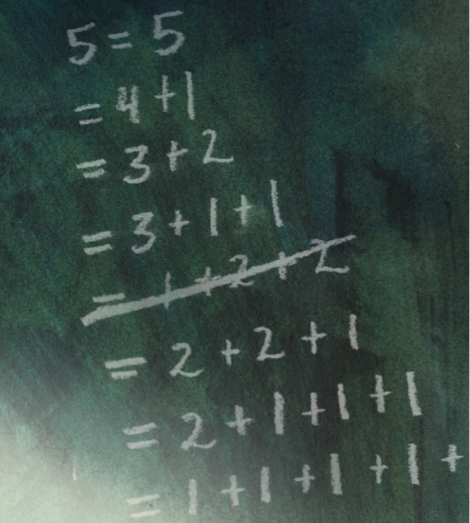
Note: Look at Ramanujan’s slate. He’s trying to find the partitions of 5, too. Why does he cross out 1 + 2 + 2? Discuss! Notice he has also written down 2 + 2 + 1. So, he’s wrestling with the idea of order. Do we consider 1 + 2 + 2 and 2 + 2 + 1 different partitions because they are in a different order? Or are they the same? Mathematicians have decided to call the ones where order doesn’t matter partitions (like the ones above), and the once where order matters compositions (so when we consider 3 + 1 and 1 + 3 different).

3. What is inside a number?
a prime factorization approach, a multiplicative approach
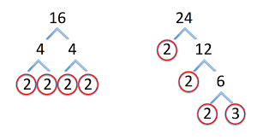 | 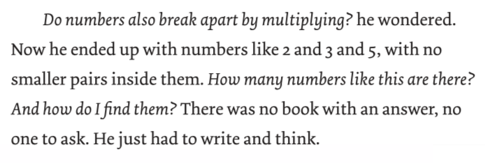

In the book I make a point never to say the word “partition” or “prime.” It would be fun to try to read these passages and try to figure out what kinds of numbers Ramanujan is thinking about, and then come up with names for them. After all, “ No one told Ramanujan how math is supposed to be done, so he did it his own way. He devised his own symbols.”

